**LARSEN AND TOUBRO LIMITED**

**SAFETY DASHBOARD DATA MAINTENANCE**

* Safety Dashboard Data Maintenance Application

Software used:

Frontend: Microsoft Visual Studio 2010

Backend: SQL Server Management Studio 2008

Languages Used: ASP.Net with C#, HTML, JavaScript, SQL

**Layout of the Application**

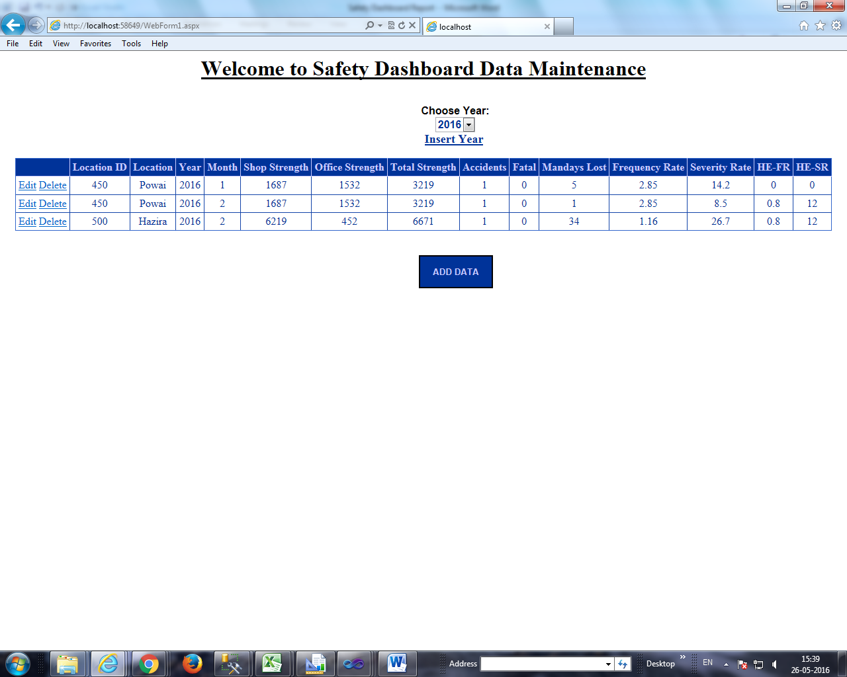

Based on the selected year from the dropdown list, data in the dashboard is displayed. Paging is added for displaying all data. Dashboard displays 9 rows at a time in a grid.

Used Sql Data Source, Gridview, Button, LinkButtons, Image, Label property of Visual Studio.

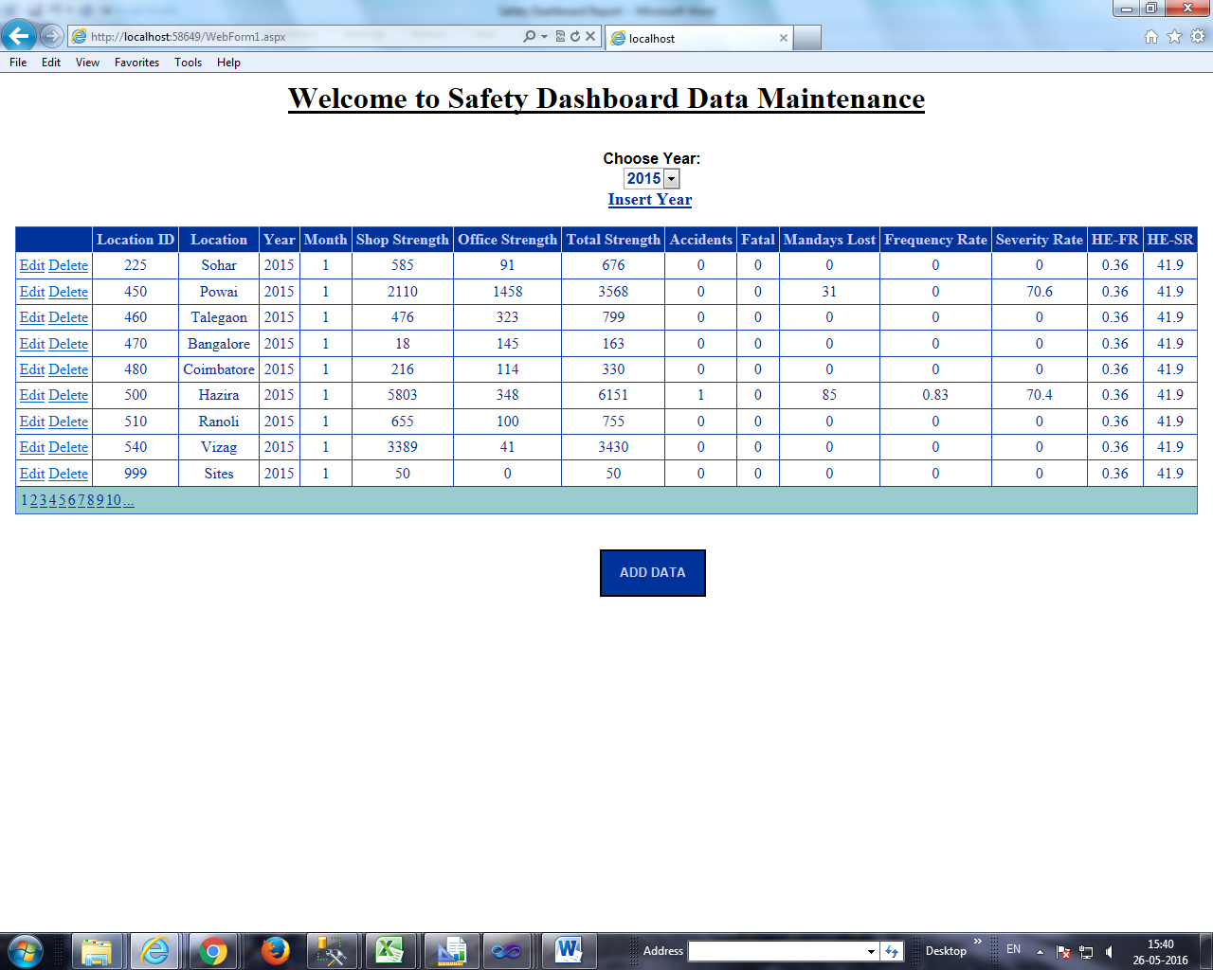

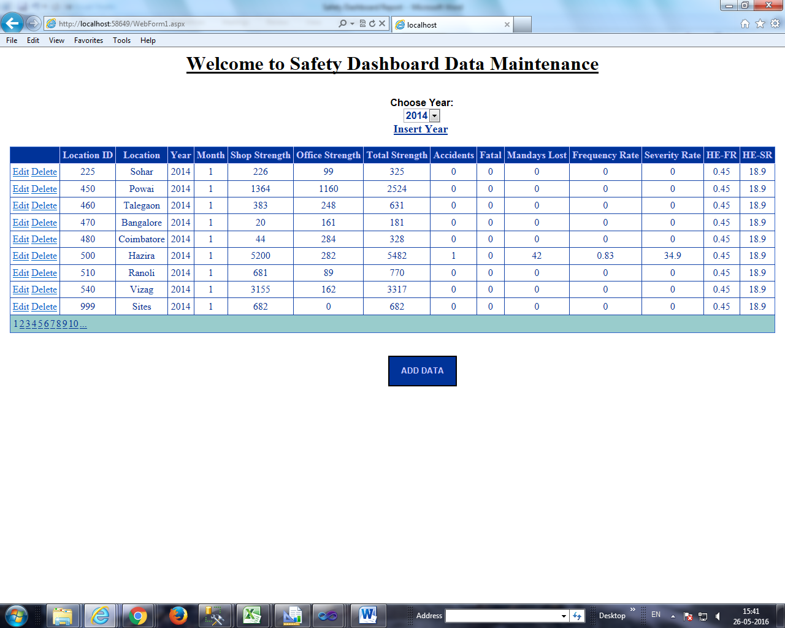

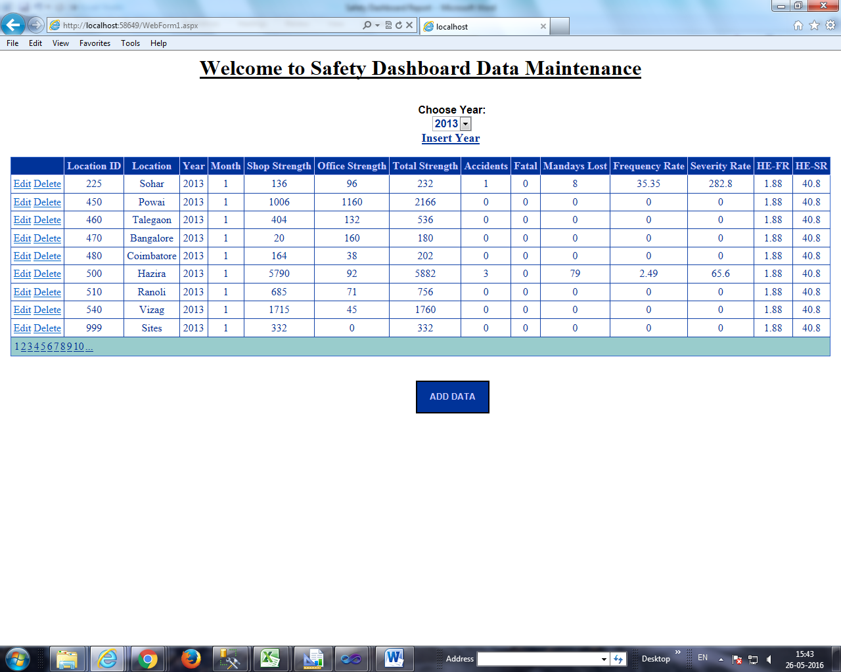

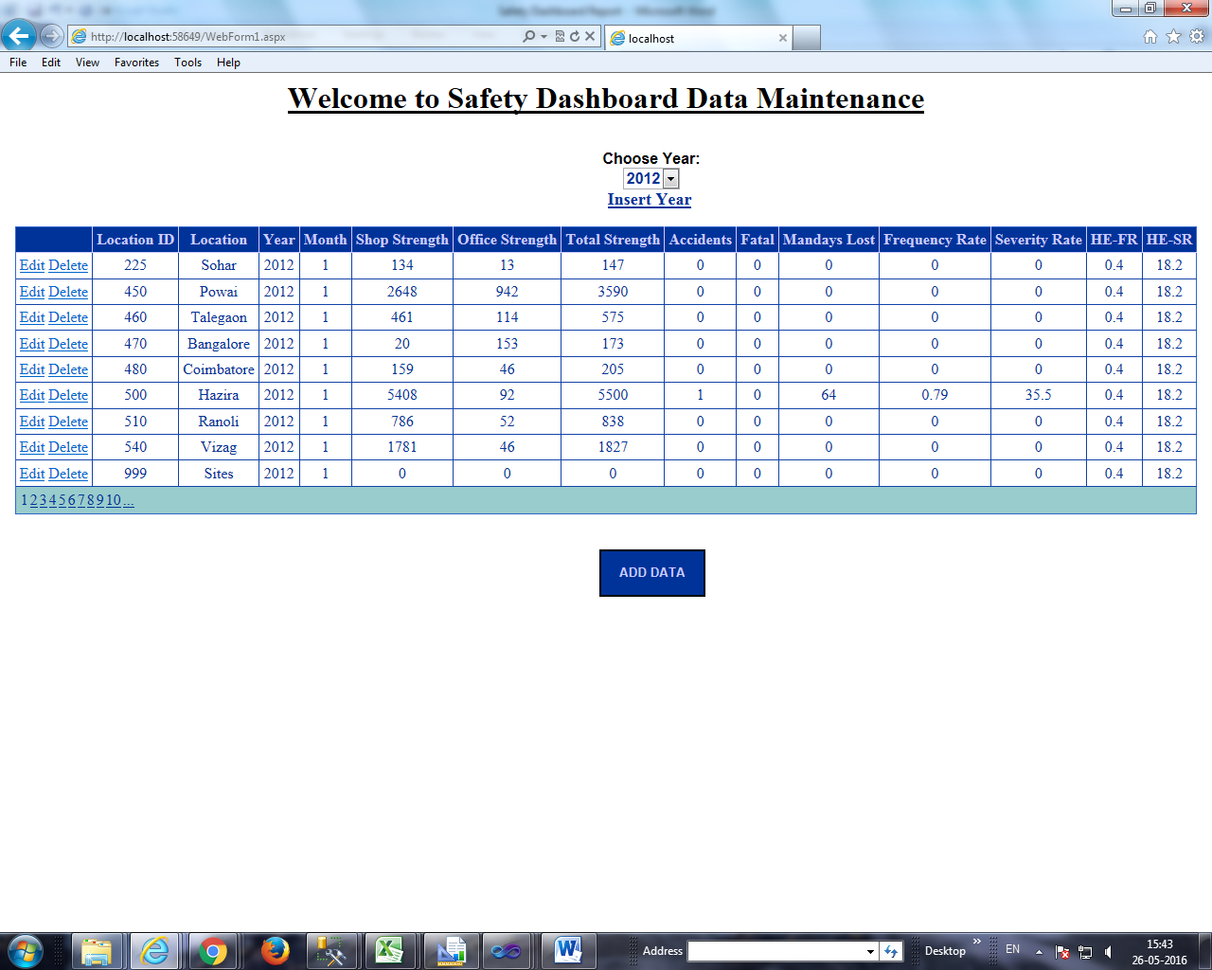

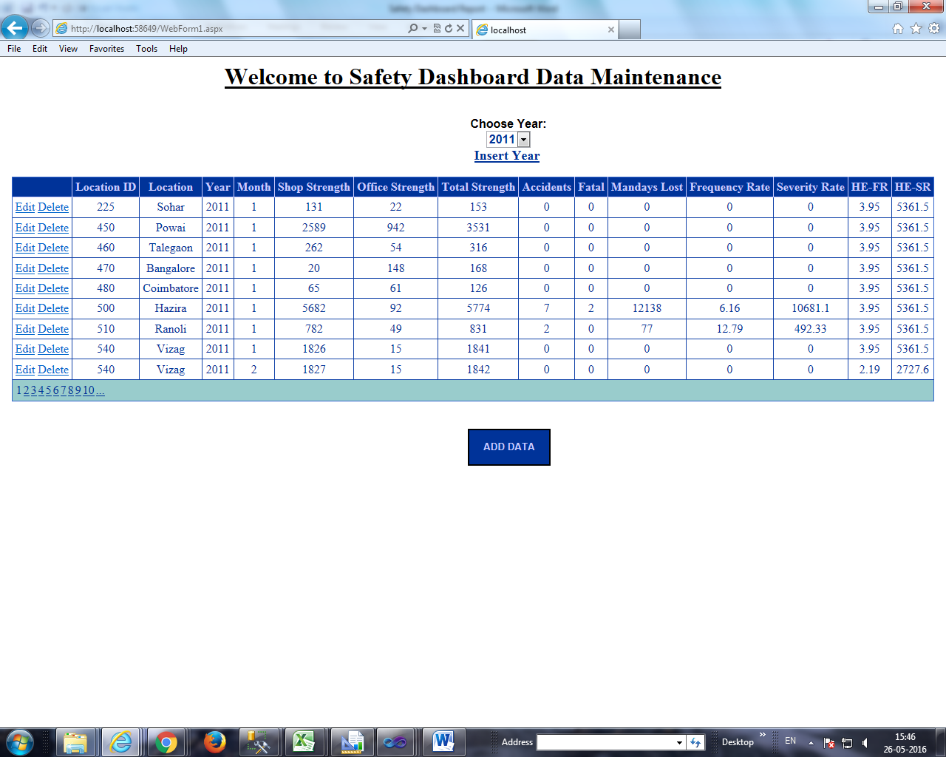

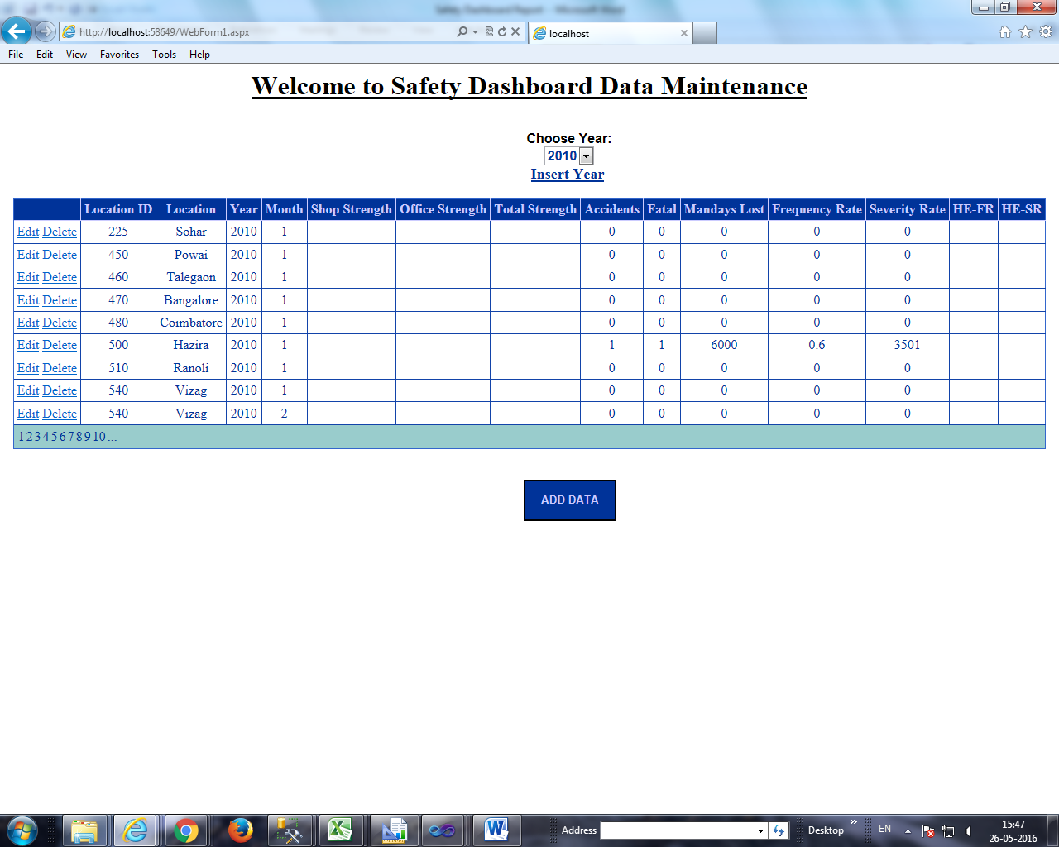

**Insertion of data**

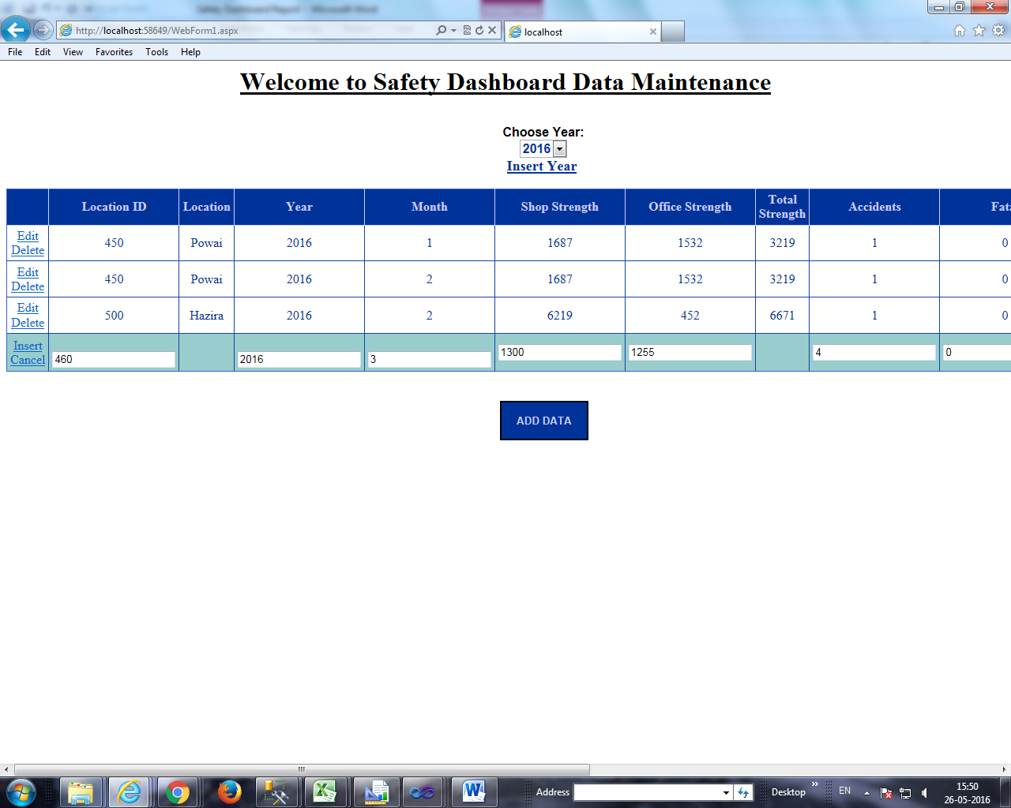

By clicking on the “**ADD DATA**”, textboxes appear for insertion of data.

After clicking on the “**Insert**” link button, data is inserted. Insertion of data is done by using C# code. Data in Location field is added automatically .This is done through SQL Query. Total Strength is calculated by the system by the user input value of Shop Strength and Office Strength. The “**Cancel**” link button restores the application.

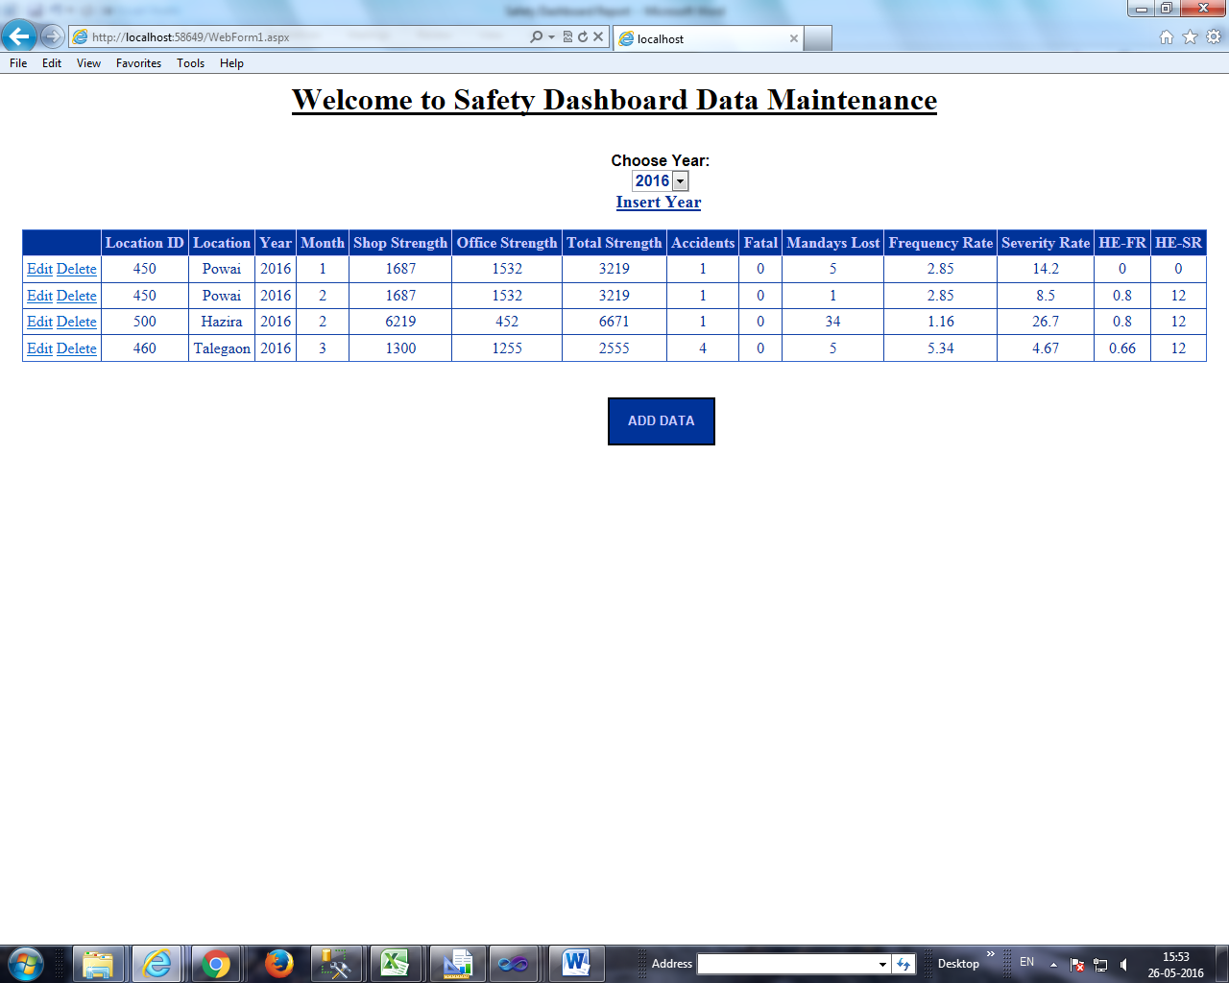

If “**Insert**” Link Button is clicked without adding any data, then following messages are displayed. Used Required Field Validator, Validation Summary property.

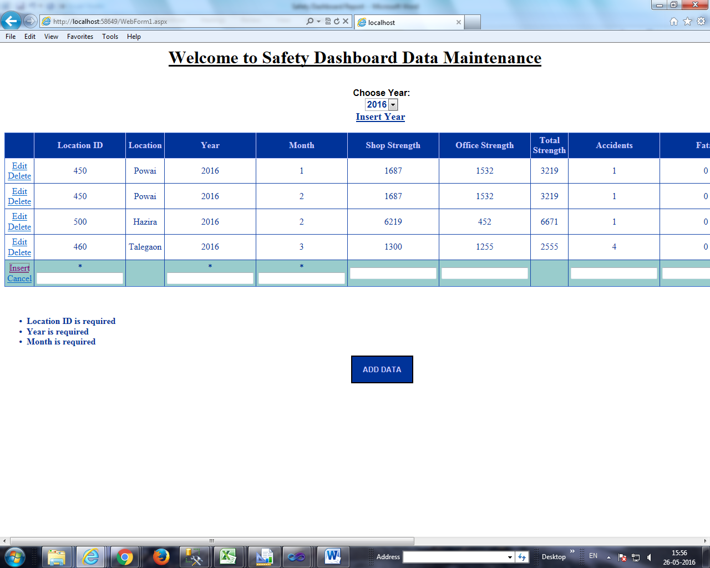

**Editing of Data**

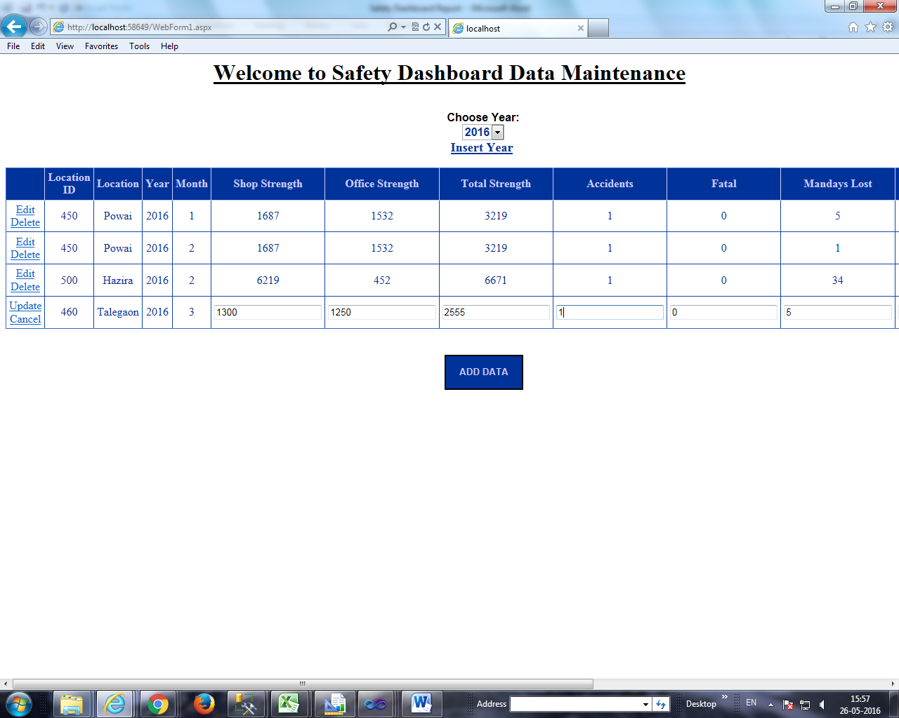

By clicking on “**Edit**” Link Button, data can be updated. Location ID, Location, Year, Month cannot be updated as they are primary keys in the database table.

Data is updated by clicking on update link Button.

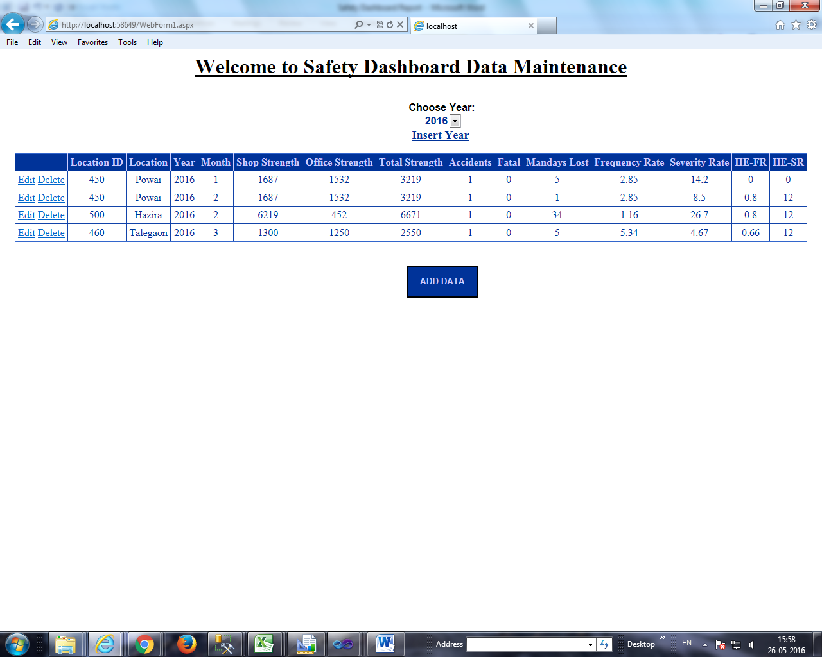

**Deletion of Data**

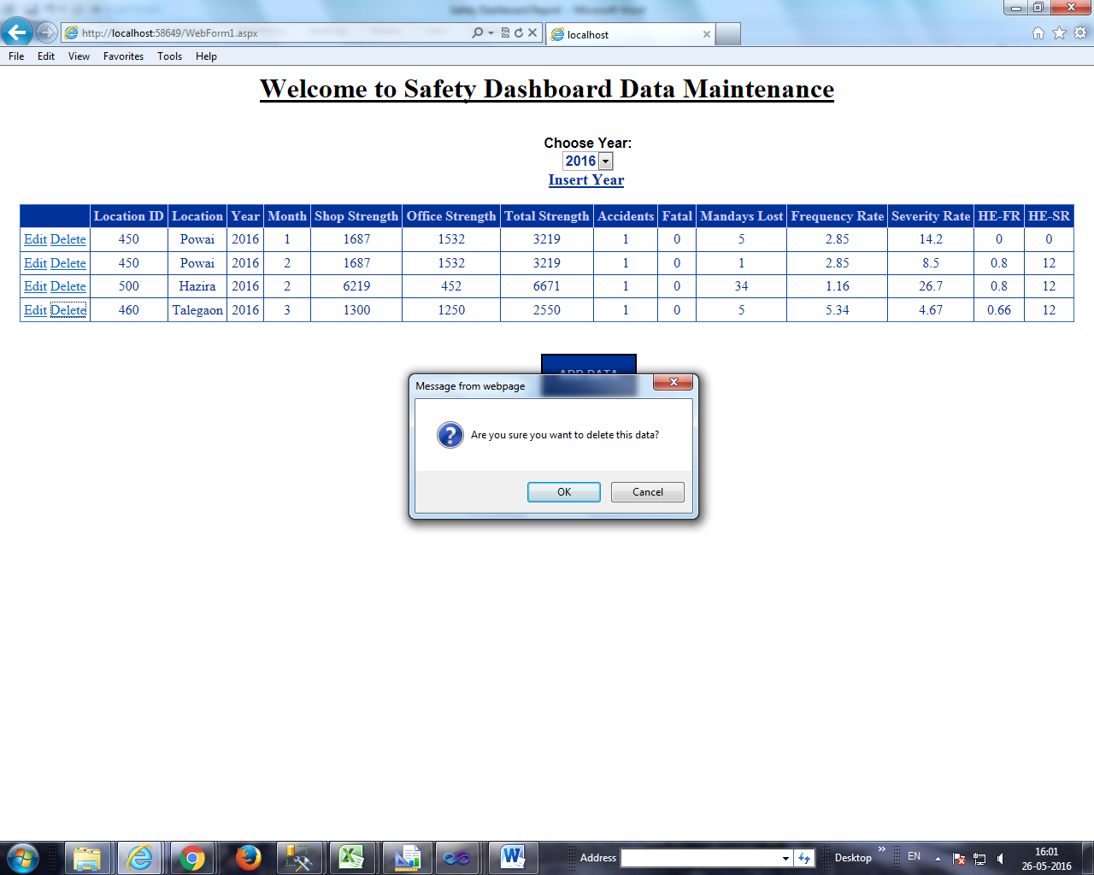

By clicking on the “Delete” Link Button, pop up confirmation box appears. This is done through JavaScript.

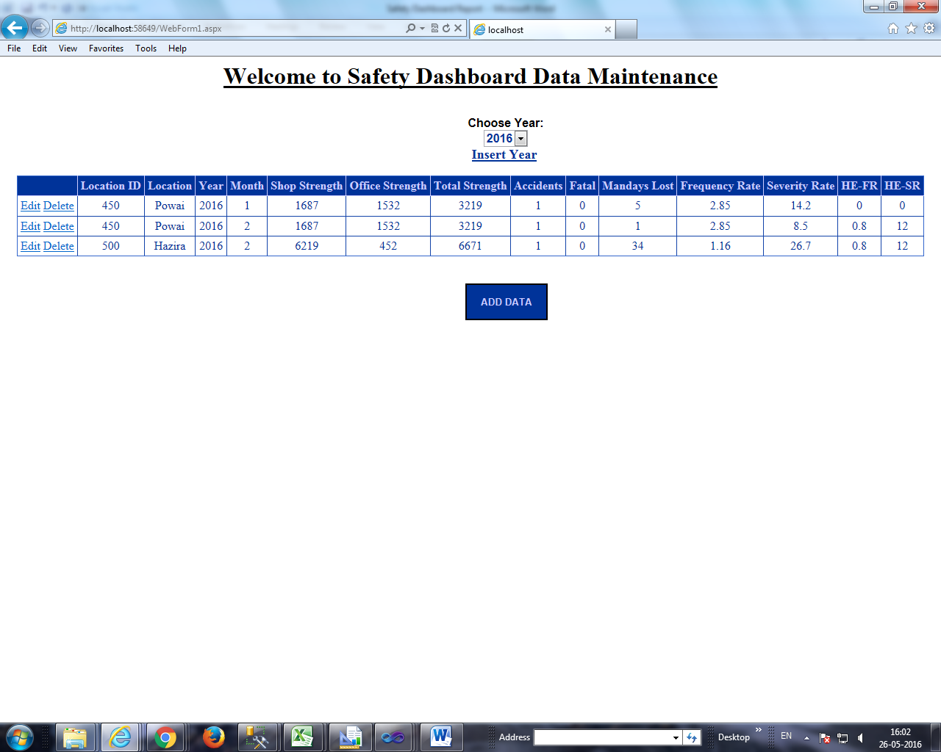

**Automatic updation of HE-FR and HE-SR Data**

The user can insert data for different locations for a particular month without entering HE-FR and HE-SR data. Data of these columns gets updated automatically. The HE-FR and HE-SR data can be updated by updating the data of the location with minimum location ID.

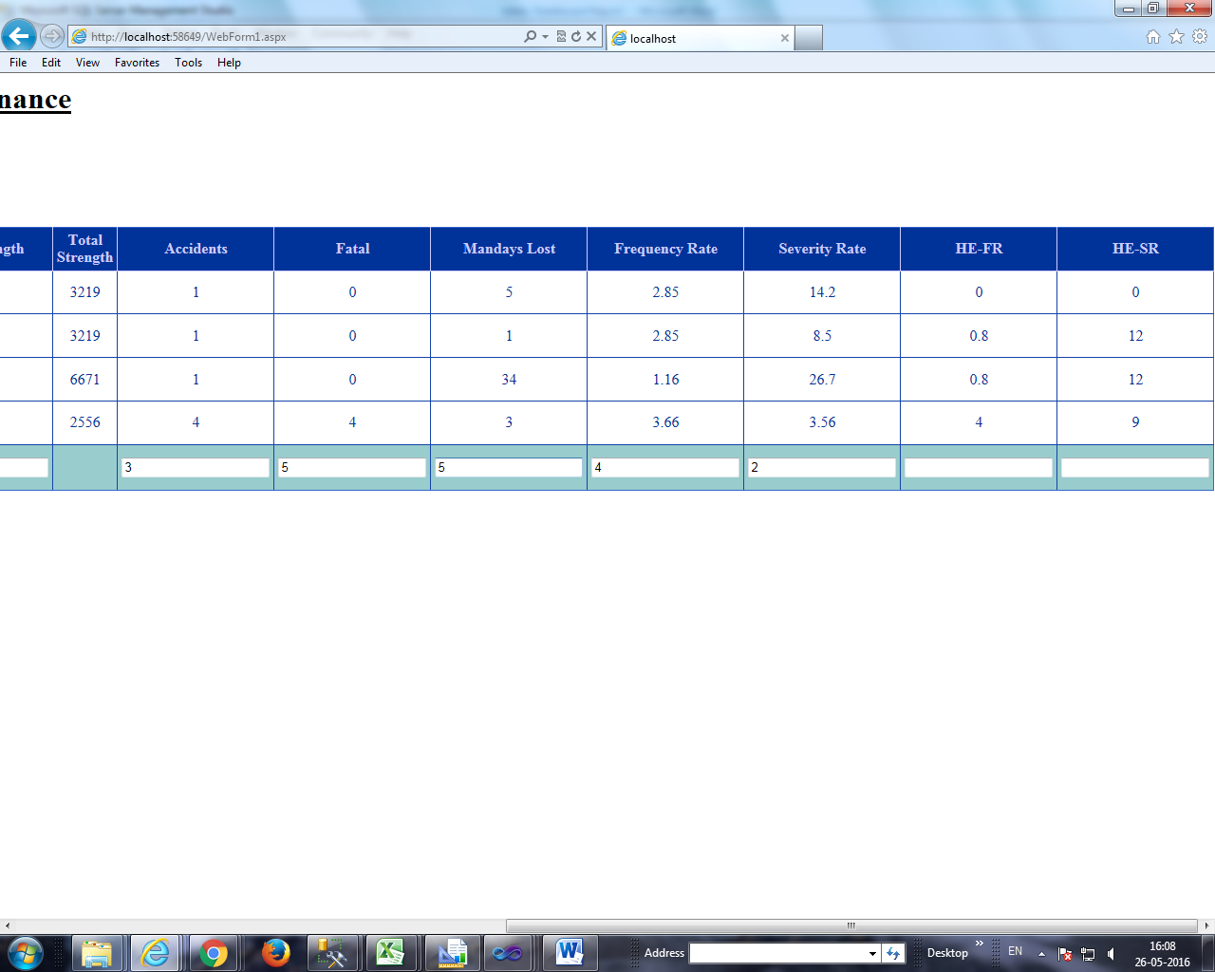

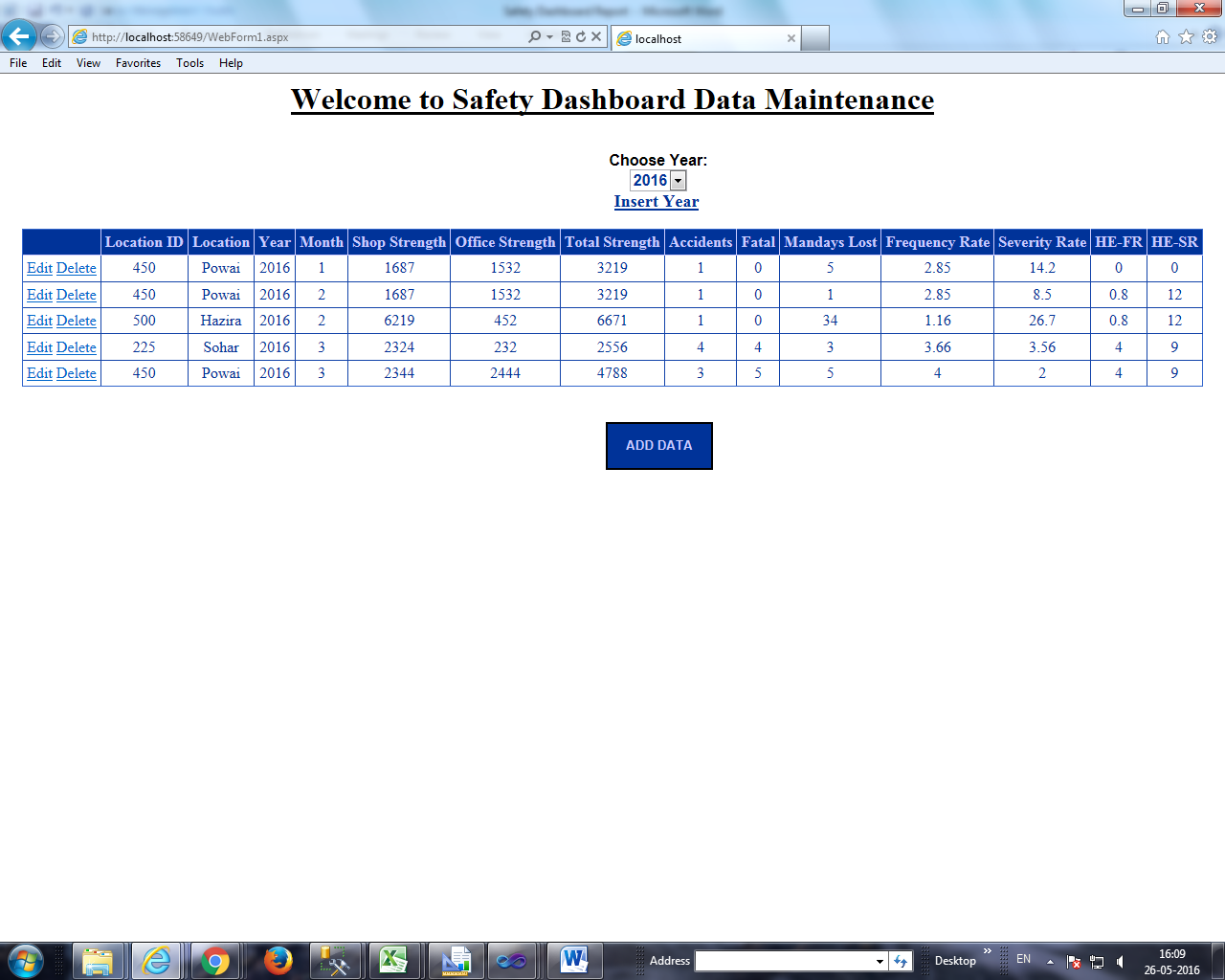

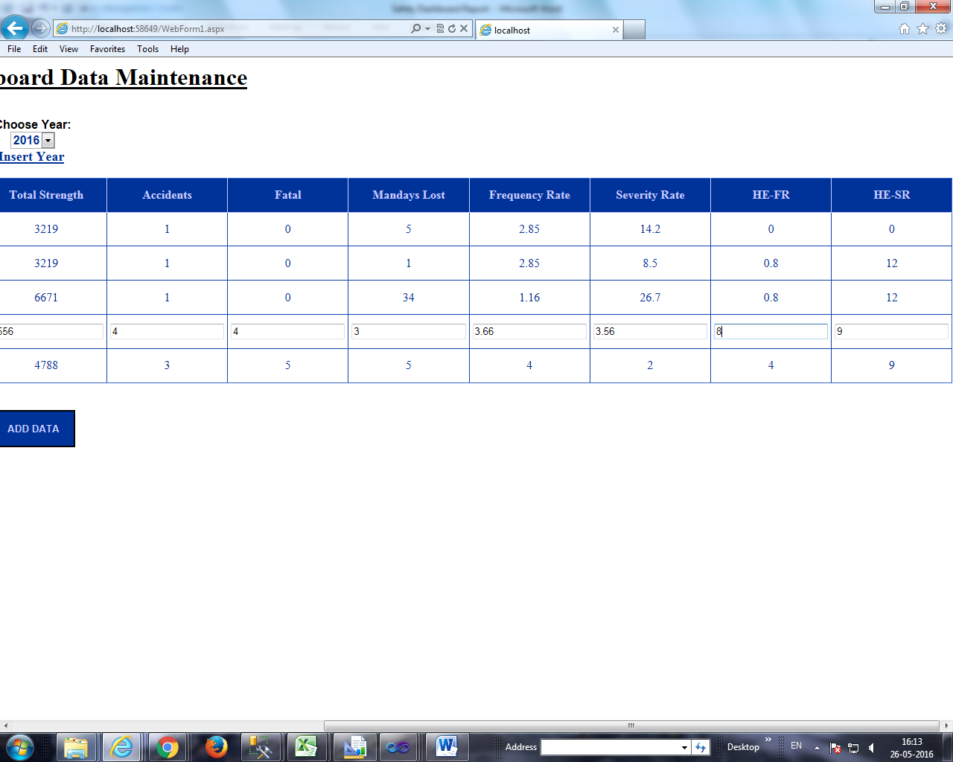

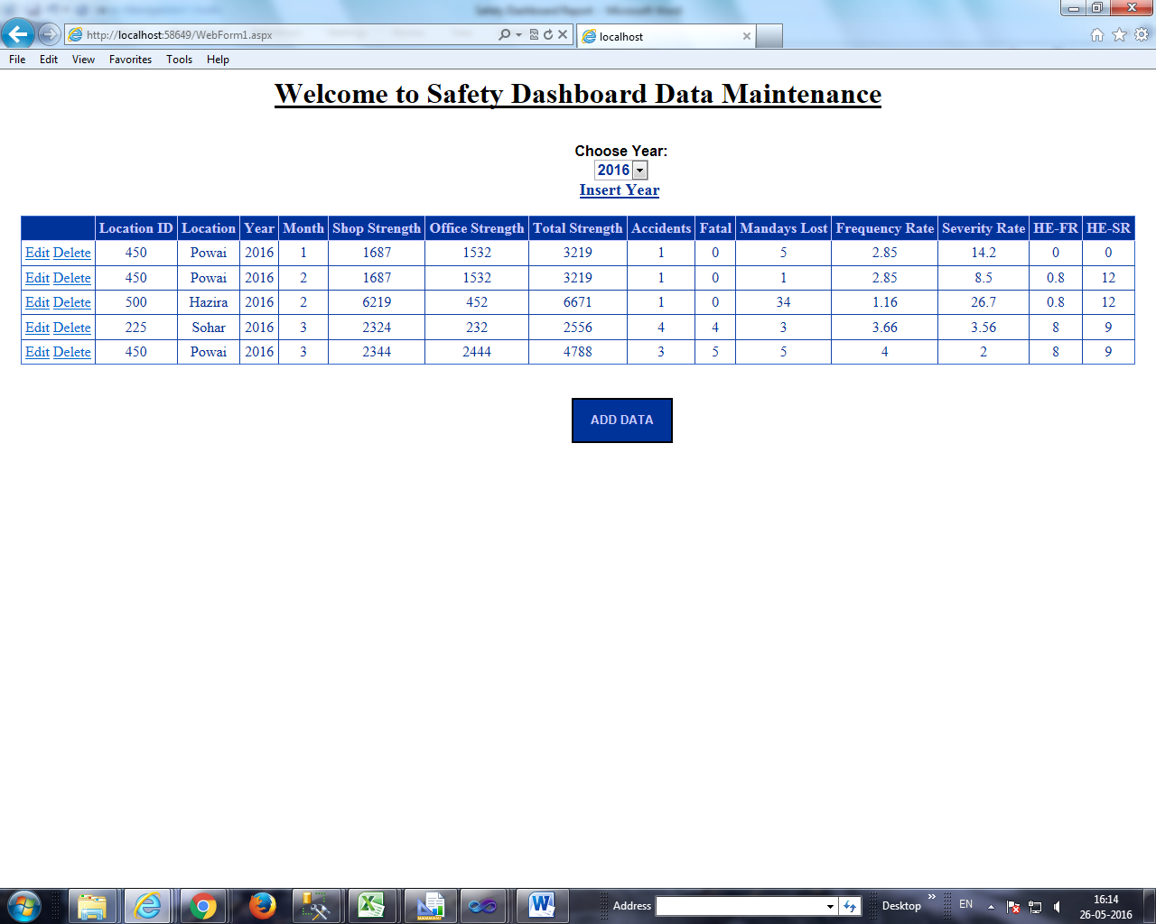

**Year Insertion**

User can insert year value by clicking on the “Insert Year” link button. A new webpage opens where user can insert year by click on the **insert** button.The **Back** button redirects user to the dashboard.

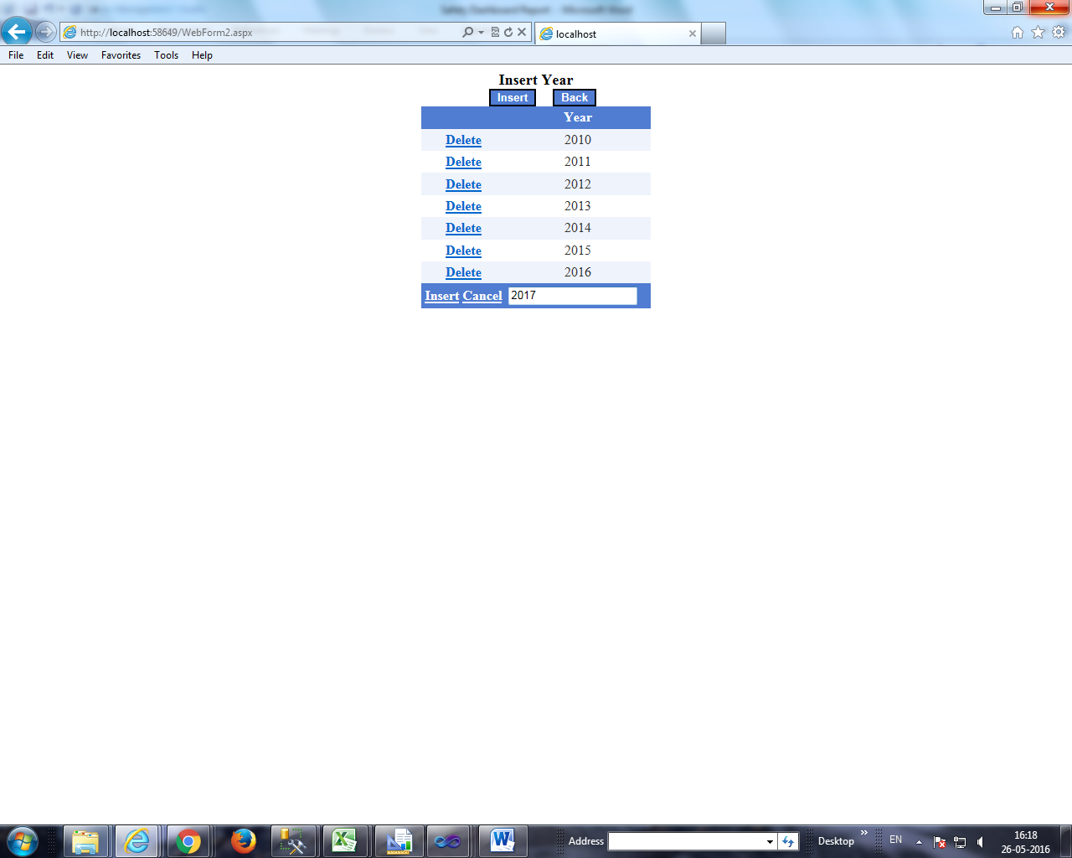User can insert and view the data of year 2017 in the dashboard.

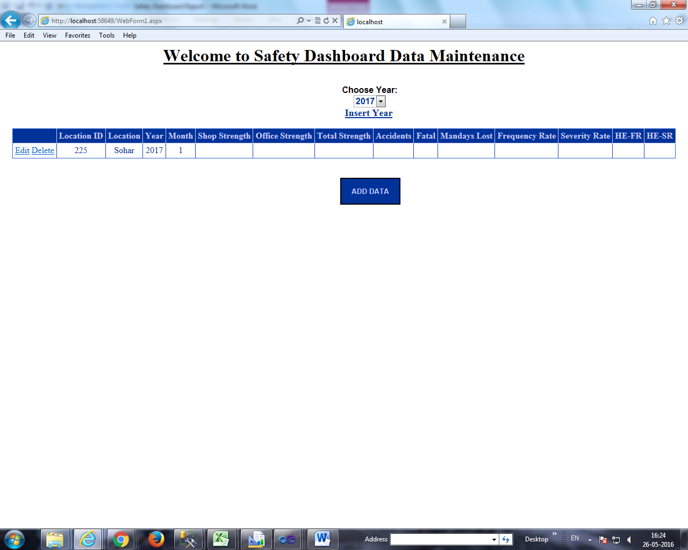

HE-IC Safety Statistics Report

Software Used: SQL Server Management Studio 2008, Microsoft SQL Server Report Builder

**Layout of the Report**

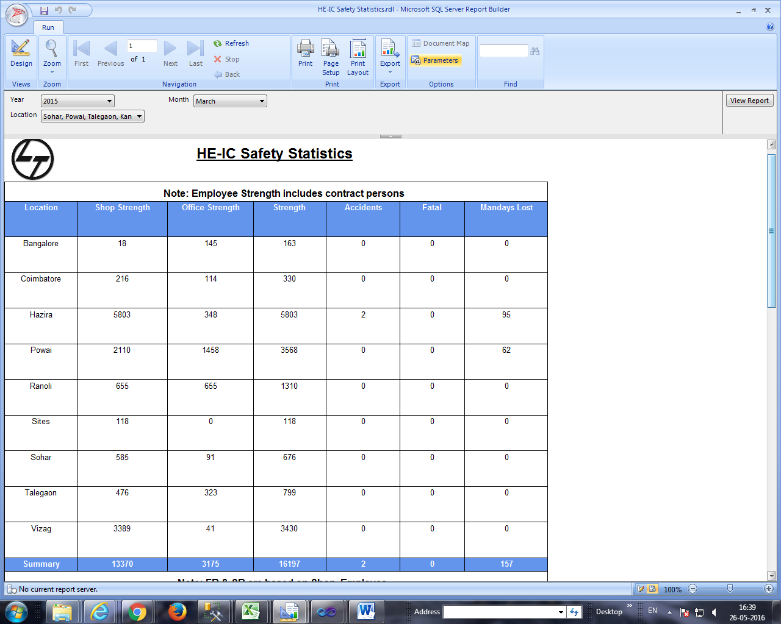

This dashboard report shows data in the form of tables and gauges. It comprises of three tables and two gauges. Year,Month and Location are considered as parameters in this report.

The First Table displays Location, Shop Strength, Office Strength, Strength,Accidents,Fatal and MandaysLost values.The summary displays the total values.

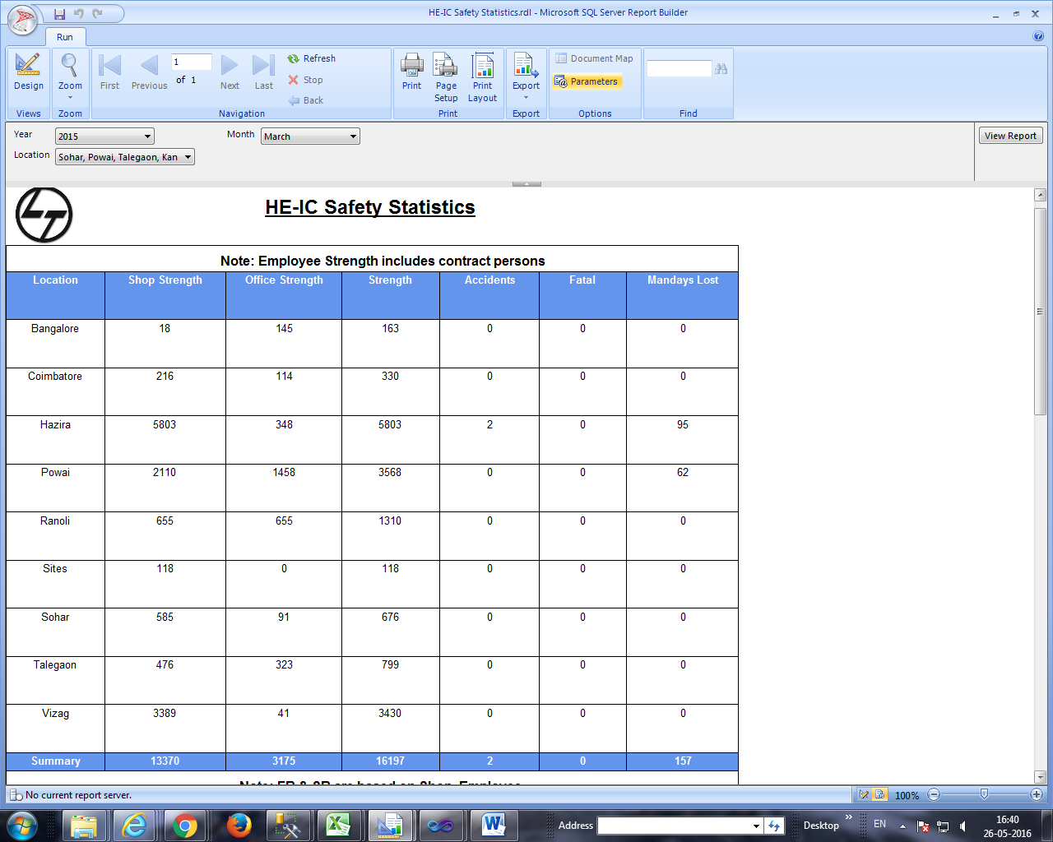

The Second Table displays Location and Frequency Rate values and the Third Table displays the Location and Severity Rate values. The font colour of the values changes based on measure ranges.

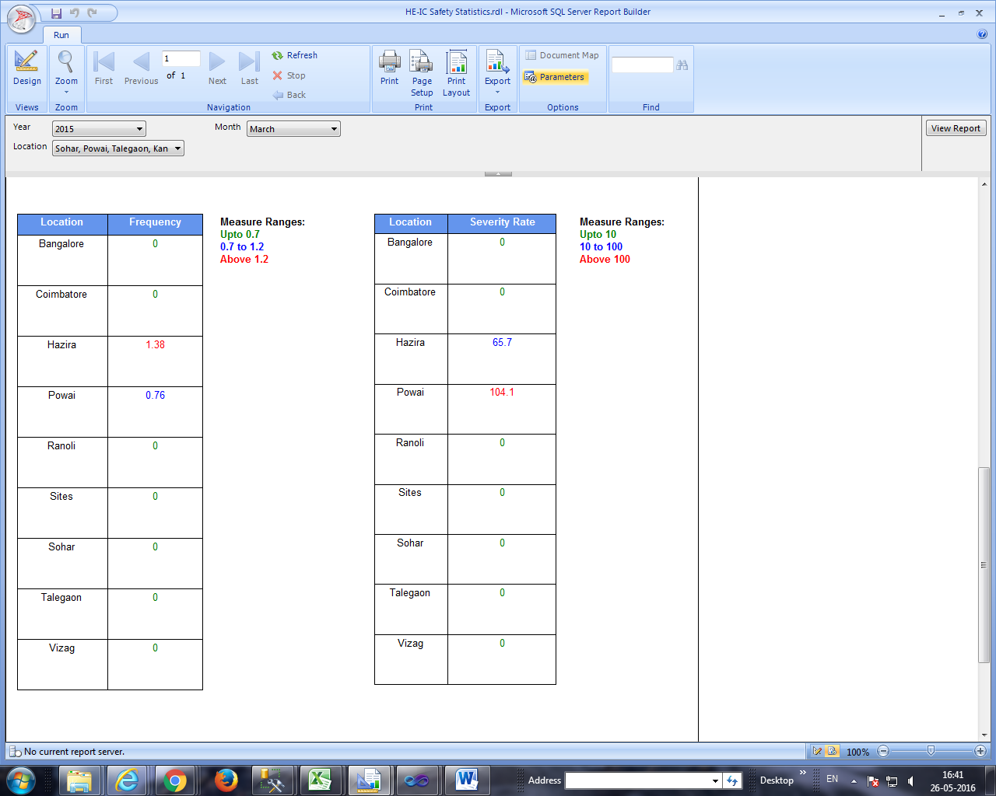

The two gauges points to the average HE Frequency Rate and average HE Severity Rate.

